SYSTEM DESIGN DOCUMENT
Redis Streams-Based Asynchronous Data Processing and Qdrant Semantic Search System
Version 1.0
Prepared for: Project Guide / Architecture Review / Engineering Team
July 2026

Table of Contents

1. Design Document Purpose
This document defines the technical design of an asynchronous data processing and semantic search platform. Unlike the companion Operational Document, which describes how to run and monitor the system, this document explains how the system is architected internally, the reasoning behind each design decision, and how its components interact.
The system is designed around the following processing pipeline:
Redis Streams
|
v
Redis Consumer Groups
|
v
Python Processing Services
|
v
Embedding Model
|
v
Qdrant Vector Database

The design supports the following capabilities:
- Document ingestion
- Student data processing
- Employee data processing
- Asynchronous message processing
- Message validation
- Priority-based processing
- Scheduled processing
- Retry handling with exponential backoff
- Dead Letter Queue processing
- Email notifications
- Vector embedding generation
- Qdrant vector storage
- Semantic similarity search
- Docker-based deployment

2. Design Goals
Goal | Description
Asynchronous Processing | Producers and consumers operate independently
Reliability | Messages are not lost during normal processing failures
Scalability | Consumers can be scaled independently
Fault Tolerance | Temporary failures are retried
Recoverability | Permanently failed messages are moved to DLQ
Semantic Search | Text is converted into embeddings and searched semantically
Modularity | Each major responsibility is separated into modules
Observability | Logs, pending messages, and service health can be monitored
Deployment Flexibility | Infrastructure runs using Docker
Extensibility | New streams and consumers can be added later

3. High-Level System Architecture
The system is organized as a strict top-to-bottom pipeline. Producers publish onto Redis Streams; Redis Consumer Groups distribute stream entries reliably to Python consumers; a processing layer applies validation, priority, and scheduling rules; the embedding service converts text into vectors; and Qdrant persists and indexes those vectors for later retrieval.
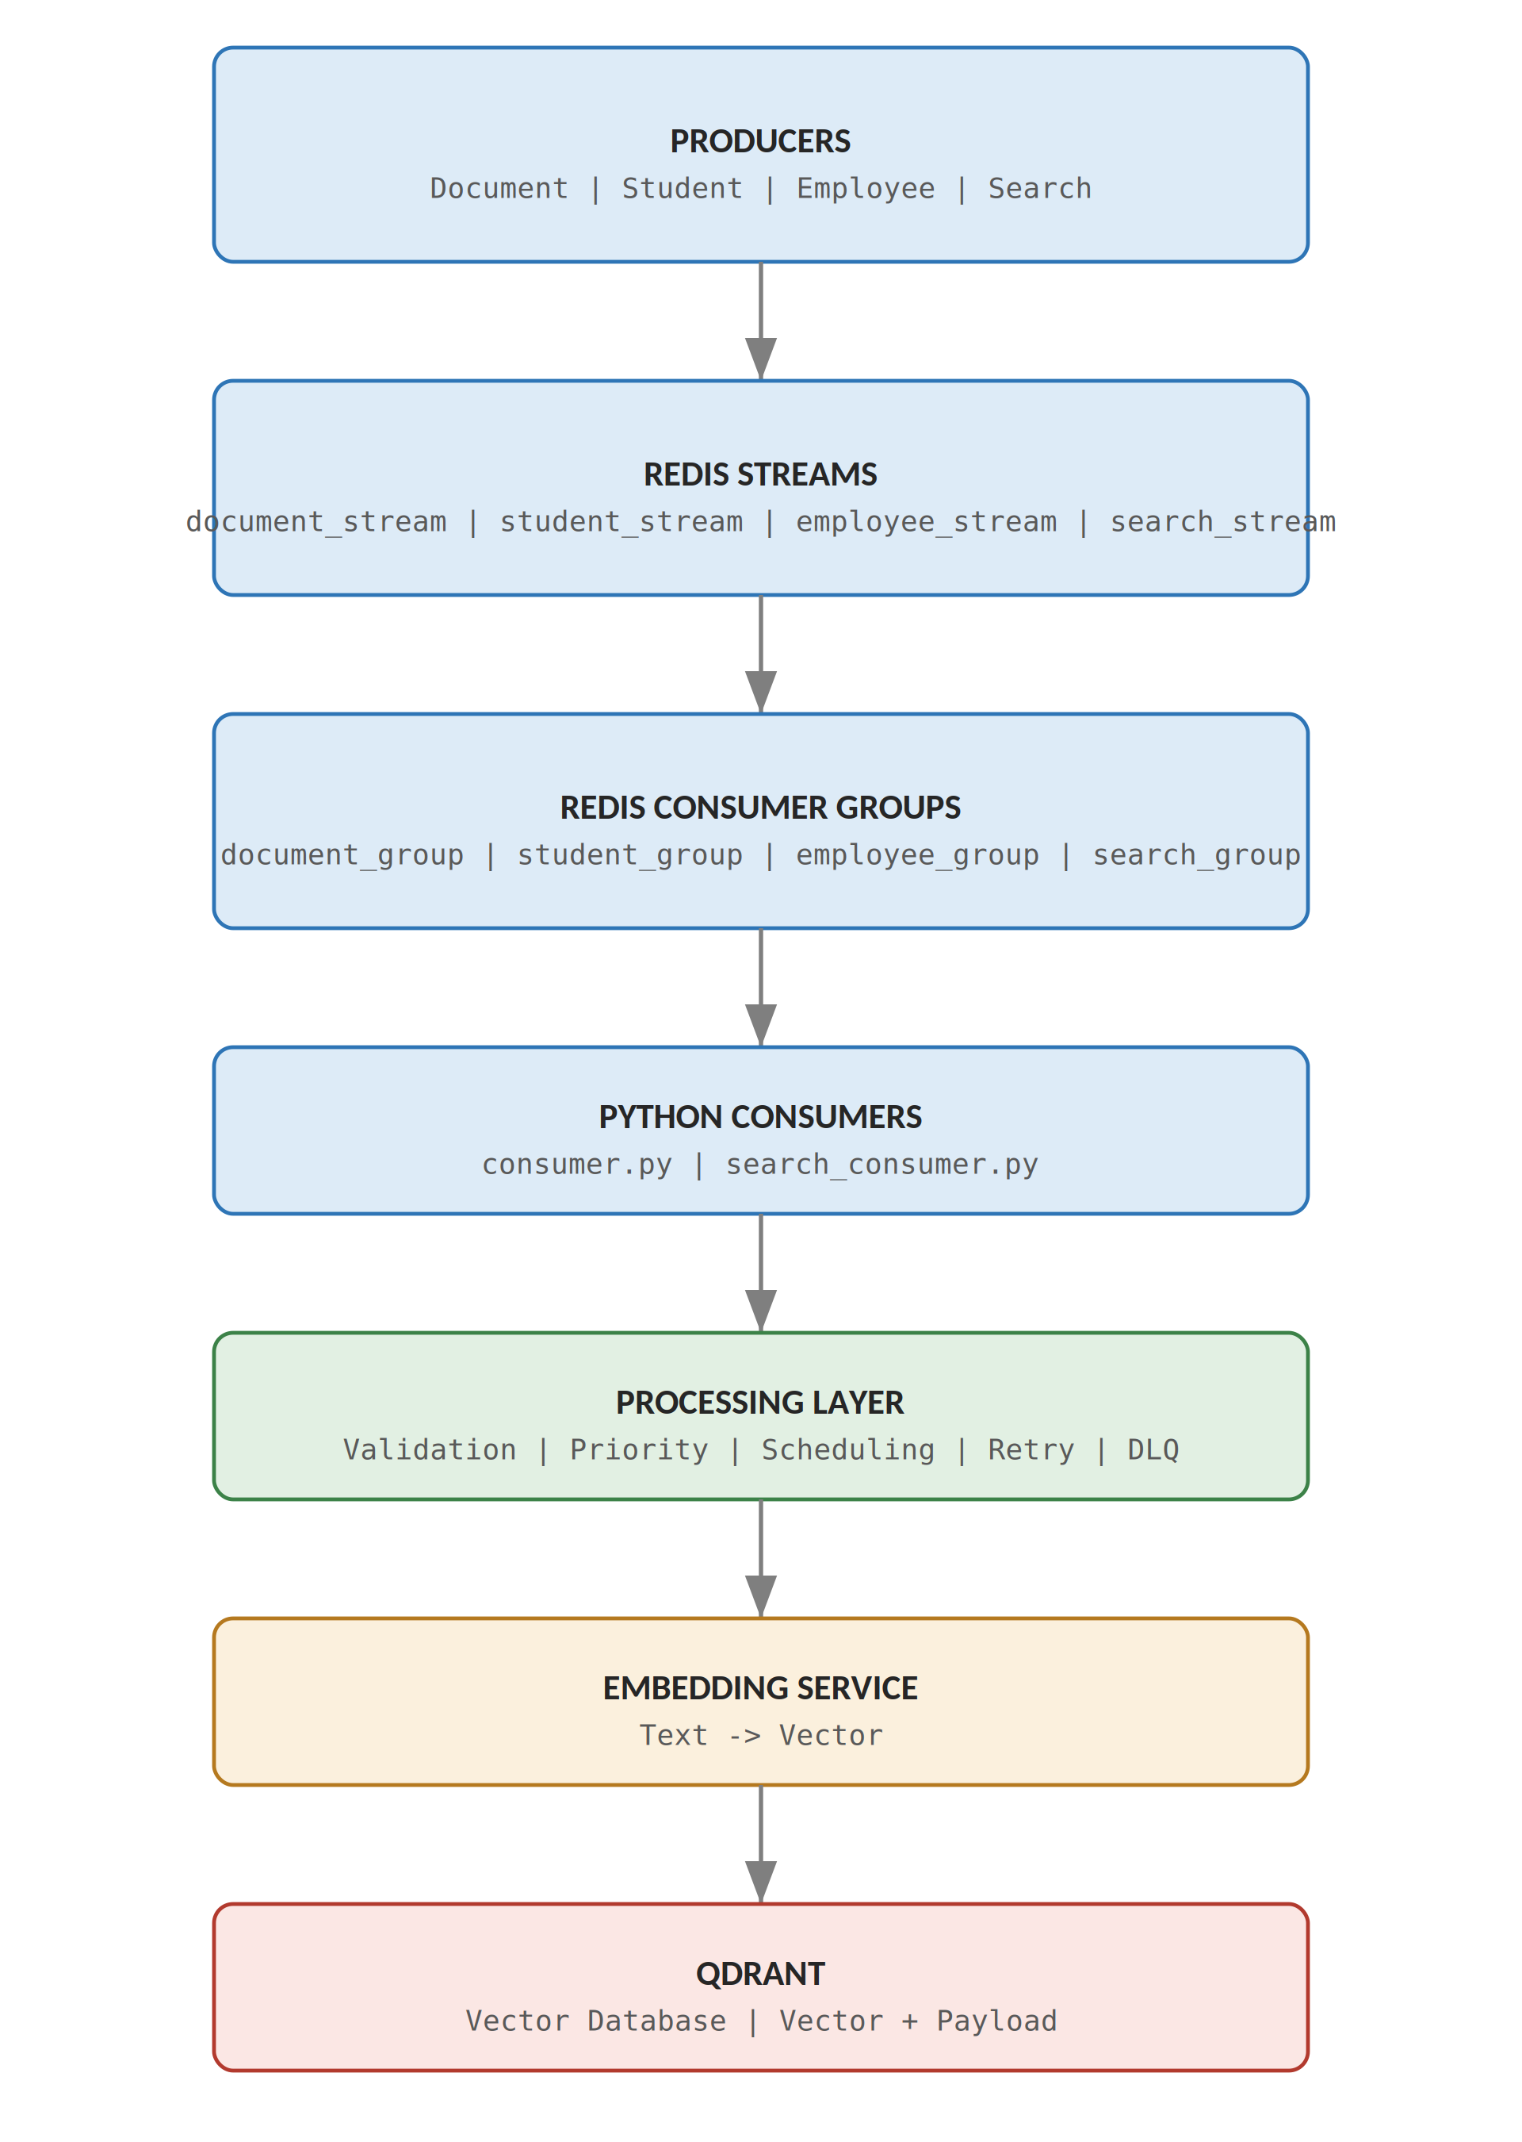
Figure 3.1 - High-level layered system architecture
Layer responsibilities:
- Producers — create and publish typed messages (document, student, employee, search) onto their dedicated stream.
- Redis Streams — durably buffer messages until a consumer group reads and acknowledges them.
- Redis Consumer Groups — guarantee that each stream entry is delivered to exactly one consumer within the group, with tracked pending state.
- Python Consumers — host the business logic that turns a raw stream entry into a fully processed record or search result.
- Processing Layer — applies validation, priority ordering, execute_at scheduling, retry accounting, and DLQ routing.
- Embedding Service — converts validated text into a fixed-length numerical vector using a Sentence Transformer model.
- Qdrant — stores each vector alongside its metadata payload and serves similarity search queries.

4. Detailed Component Architecture
Component | Responsibility | Main Interface
Producer | Publishes messages | XADD
Redis Stream | Buffers messages | Stream API
Consumer Group | Reliable distribution | XREADGROUP
Python Consumer | Processes messages | Python service
Validation Module | Validates fields | Validation functions
Retry Handler | Controls retries | Retry functions
DLQ Handler | Handles permanent failures | DLQ publisher
Email Service | Sends notifications | Email function
Embedding Service | Creates vectors | embed_text()
Qdrant Service | Stores vectors | Upsert API
Search Service | Searches vectors | Query API
Search Consumer | Processes search requests | Search stream

5. Module-Level Design
The project is organized into focused, single-responsibility modules:
IITM/
|
+-- consumer.py
+-- search_consumer.py
+-- producer.py
|
+-- config.py
+-- redis_client.py
|
+-- validation.py
+-- retry_handler.py
+-- dlq_handler.py
+-- email_service.py
|
+-- embedding_service.py
+-- qdrant_service.py
+-- qdrant_helper.py
+-- search_service.py
|
+-- dlq_review.py
+-- requirements.txt
+-- docker-compose.yml
`-- README.md

File | Responsibility
consumer.py | Entry point for document, student, and employee stream consumers
search_consumer.py | Entry point for the search-stream consumer
producer.py | Publishes sample or production messages onto the streams
config.py | Centralized configuration (hosts, ports, thresholds, model name)
redis_client.py | Shared Redis connection and stream/consumer-group helpers
validation.py | Field-level validation rules for every message type
retry_handler.py | Retry-count tracking and exponential backoff scheduling
dlq_handler.py | Publishes permanently failed messages to the DLQ stream
email_service.py | Sends success and failure notification emails
embedding_service.py | Wraps the Sentence Transformer model (embed_text())
qdrant_service.py | Upsert and collection-management calls to Qdrant
qdrant_helper.py | Point-ID generation and payload-shaping utilities
search_service.py | Query embedding and Qdrant similarity search calls
dlq_review.py | Operator utility for inspecting and reprocessing DLQ entries

6. Producer Design
Each producer follows the same lifecycle: receive data, assemble a message payload, attach required fields, and publish to the correct Redis Stream.
Producer
|
+-- Document Data
+-- Student Data
+-- Employee Data
`-- Search Command
|
v
XADD
|
v
Redis Stream

Message schemas
Message Type | Fields
document_stream | document_id, title, text, priority, retry_count, execute_at
student_stream | student_id, name, age, department, priority, execute_at
employee_stream | employee_id, name, department, role, priority, execute_at
search_stream | command, query, top_k

Each producer publishes only to its corresponding stream, keeping the three data domains and the search-command channel fully independent of one another.

7. Redis Stream Design
document_stream -> document_group -> document consumer
student_stream -> student_group -> student consumer
employee_stream -> employee_group -> employee consumer
search_stream -> search_group -> search consumer

Separate streams are used for each data domain rather than a single shared stream, for the following reasons:
- Isolation — a spike or fault in one domain cannot block another
- Independent processing — each stream has its own consumer logic
- Independent scaling — consumers can be added per stream as needed
- Different validation rules — document, student, and employee records have distinct required fields
- Independent failure handling — retry counters and DLQs are scoped per stream
- Better monitoring — XLEN, XPENDING, and XINFO are meaningful per stream rather than mixed together

8. Consumer Group Design
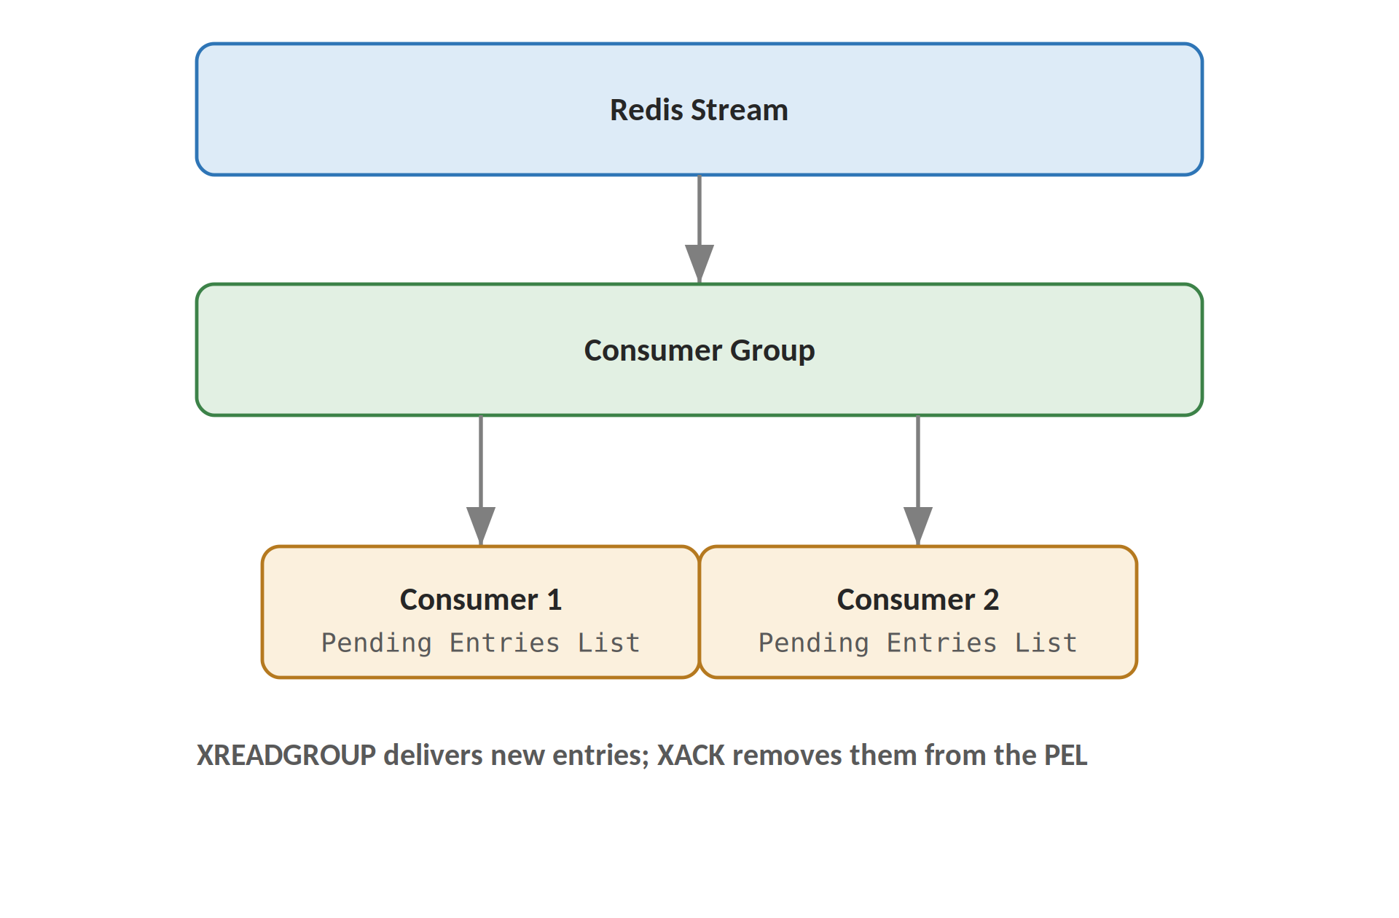
Figure 8.1 - Redis Consumer Group delivery model
Key mechanics:
- XREADGROUP delivers new (or previously undelivered) entries to a named consumer within the group.
- Each consumer has its own identity, so Redis can track which consumer currently owns which message.
- The Pending Entries List (PEL) records every message that has been delivered but not yet acknowledged.
- XACK removes a message from the PEL once it has been fully and successfully processed.
- Message ownership can be reassigned (via XCLAIM/XAUTOCLAIM) if the owning consumer fails before acknowledging.
- A message is acknowledged only after processing succeeds — partial processing never results in an XACK.

9. Document Processing Design
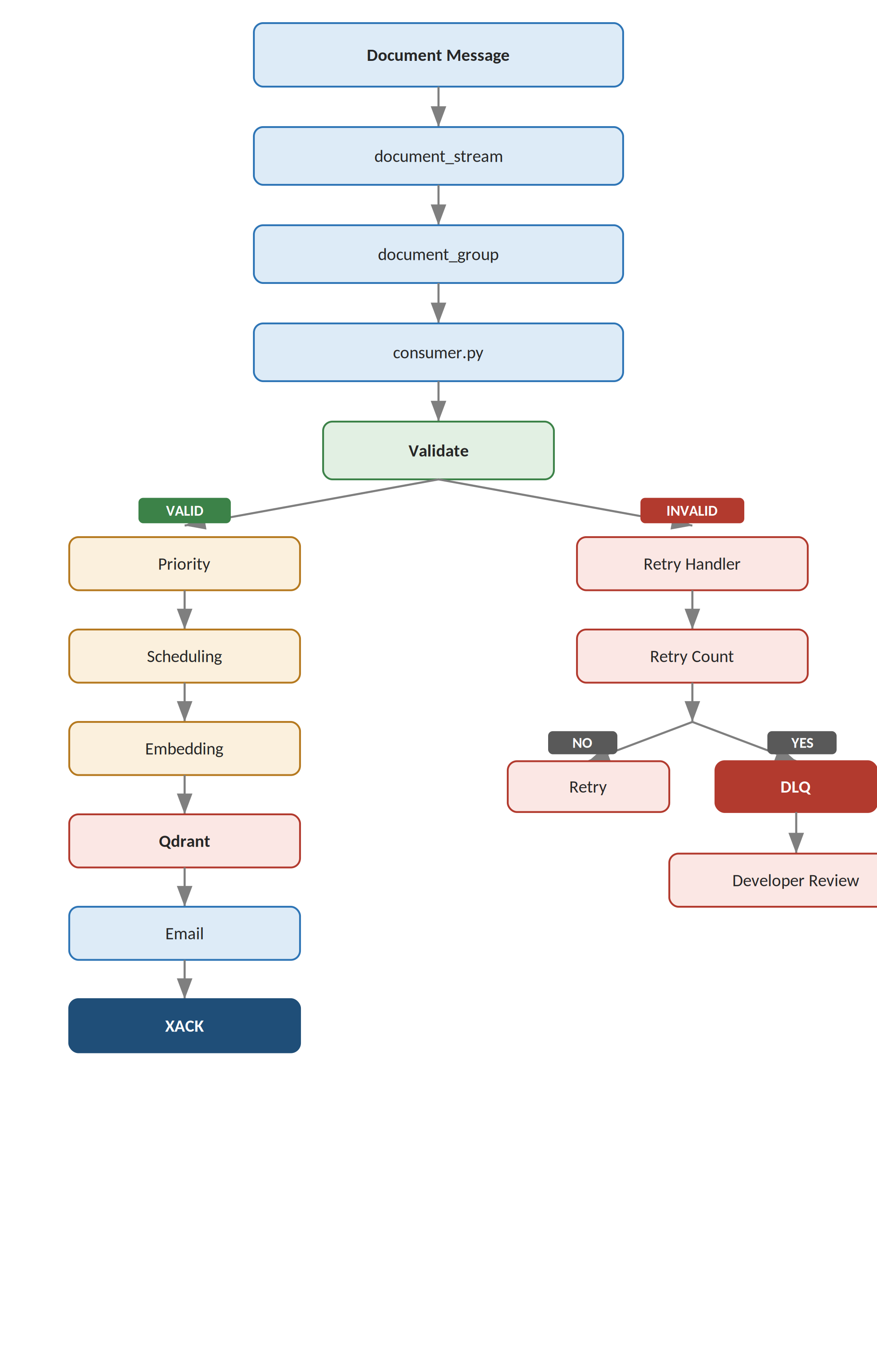
Figure 9.1 - Detailed document processing and failure-handling flow
Each stage of the flow has a distinct responsibility:
- Validate — confirms the message is well-formed before any business logic runs.
- Priority — reorders otherwise-ready messages so HIGH priority work is handled first.
- Scheduling — defers messages whose execute_at time has not yet arrived.
- Embedding — converts the document text into a vector representation.
- Qdrant — persists the vector and payload.
- Email — notifies stakeholders of success or, on the failure path, of permanent failure.
- XACK — confirms to Redis that the message is fully handled.

10. Validation Design
The validation layer runs before any business logic and checks:
Required Fields
|
+-- document_id
+-- title
`-- text

Additional Fields
|
+-- priority
+-- execute_at
`-- retry_count

Validation covers:
- Required field validation — document_id, title, and text must be present
- Type validation — fields must match their expected data type
- Empty value validation — blank strings are rejected the same as missing fields
- Priority validation — priority must be one of HIGH, MEDIUM, or LOW
- Date/time validation — execute_at, when present, must be a parseable timestamp
Invalid Message
|
v
Validation Error
|
v
Retry Handler

11. Priority Design
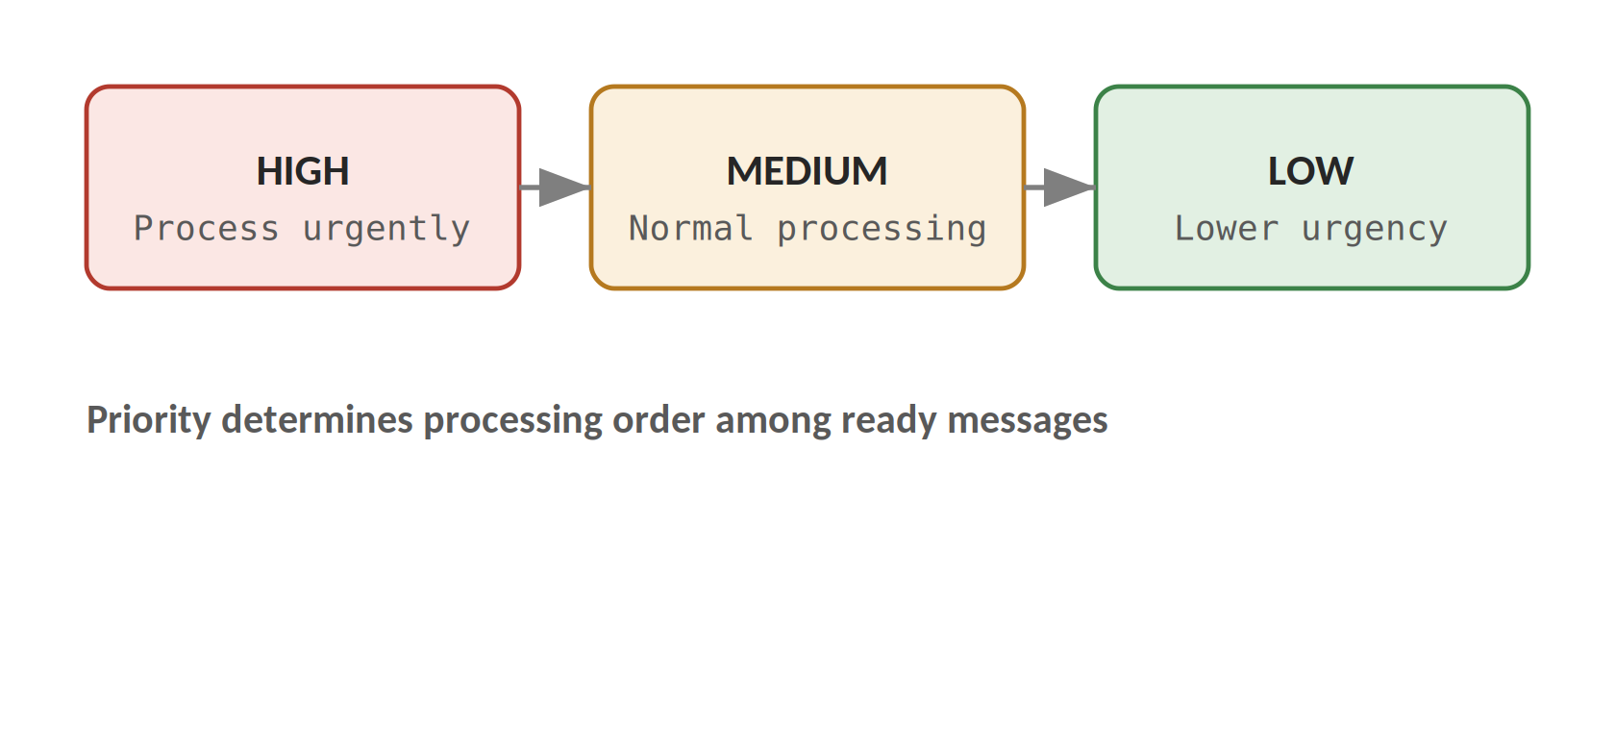
Figure 11.1 - Priority tiers
Priority is carried as a plain string field on every ingestion message and is read by the consumer immediately after validation. It does not change whether a message is processed, only the order in which ready messages are handled; the model can be extended later with additional tiers or numeric weights without changing the message schema.
Priority | Meaning
HIGH | Process urgently
MEDIUM | Normal processing
LOW | Lower urgency

12. Scheduling Design
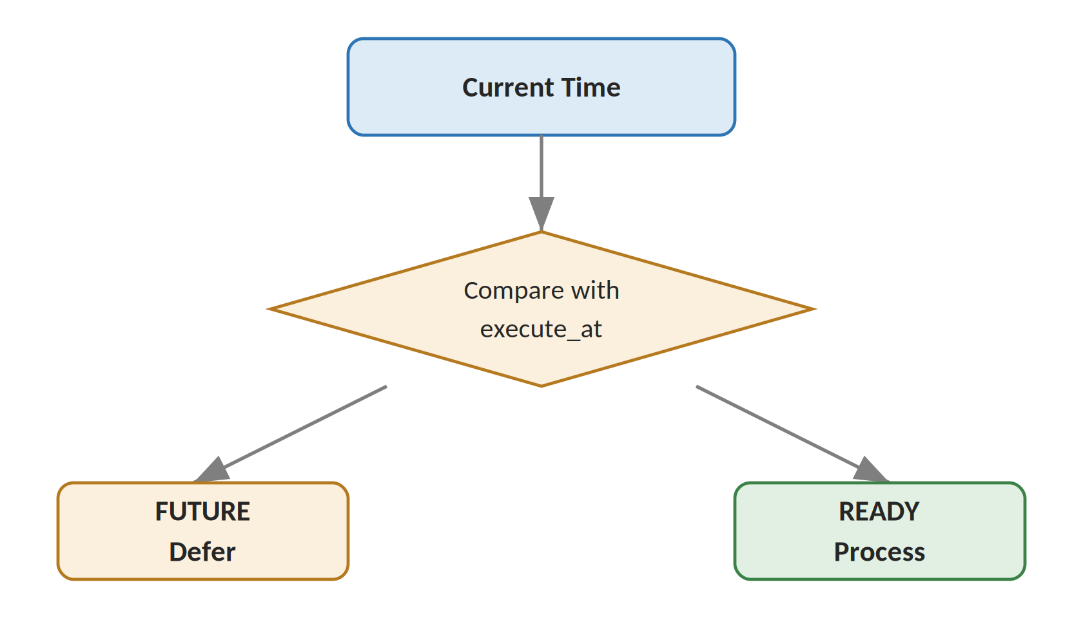
Figure 12.1 - execute_at scheduling decision
Current Time < execute_at -> message is not ready (deferred)
Current Time >= execute_at -> message can be processed

All execute_at comparisons are performed in UTC to avoid ambiguity across producer and consumer time zones.

13. Embedding Architecture
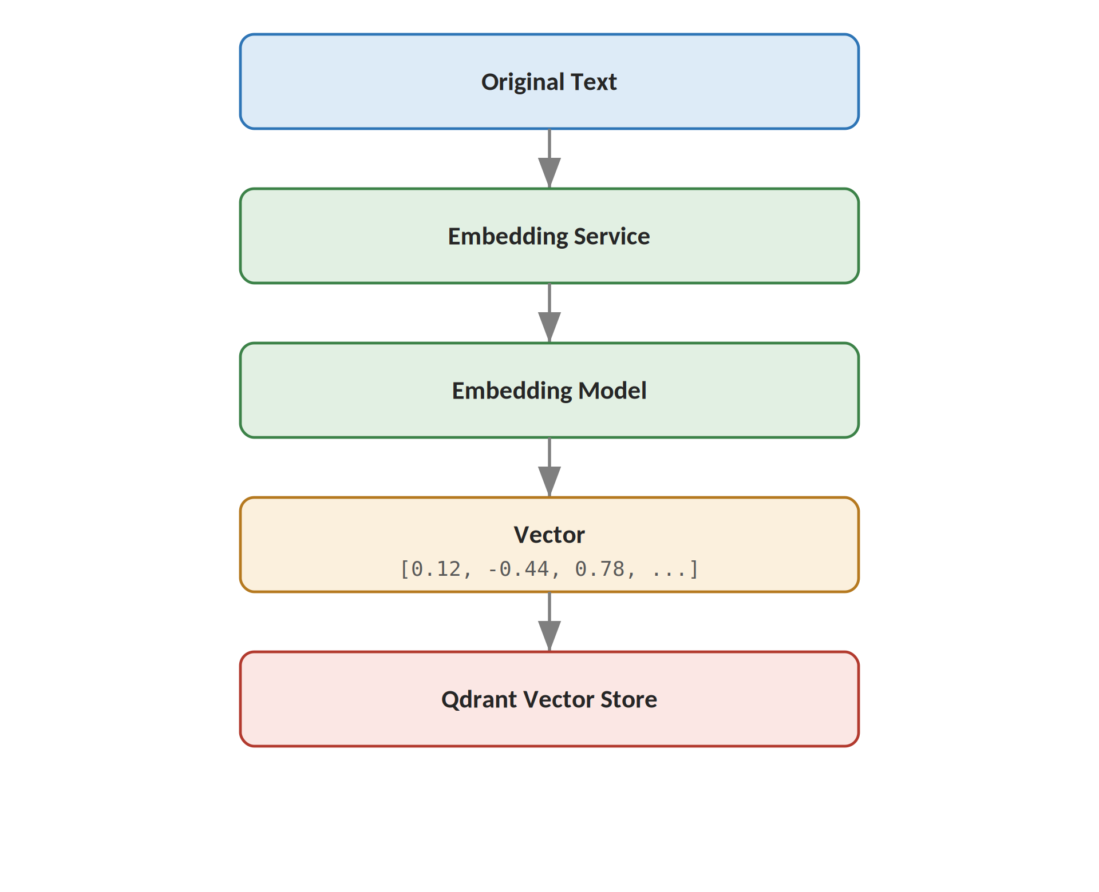
Figure 13.1 - Text-to-vector embedding pipeline
Text is passed through a Sentence Transformer embedding model, which produces a fixed-length numerical vector capturing the semantic meaning of the text rather than its literal wording. Semantically similar text — even with different vocabulary — produces vectors that are close together in the embedding space, which is what makes similarity search possible. Qdrant is used as the vector store because it is purpose-built for high-dimensional similarity search with metadata filtering.

14. Qdrant Data Model
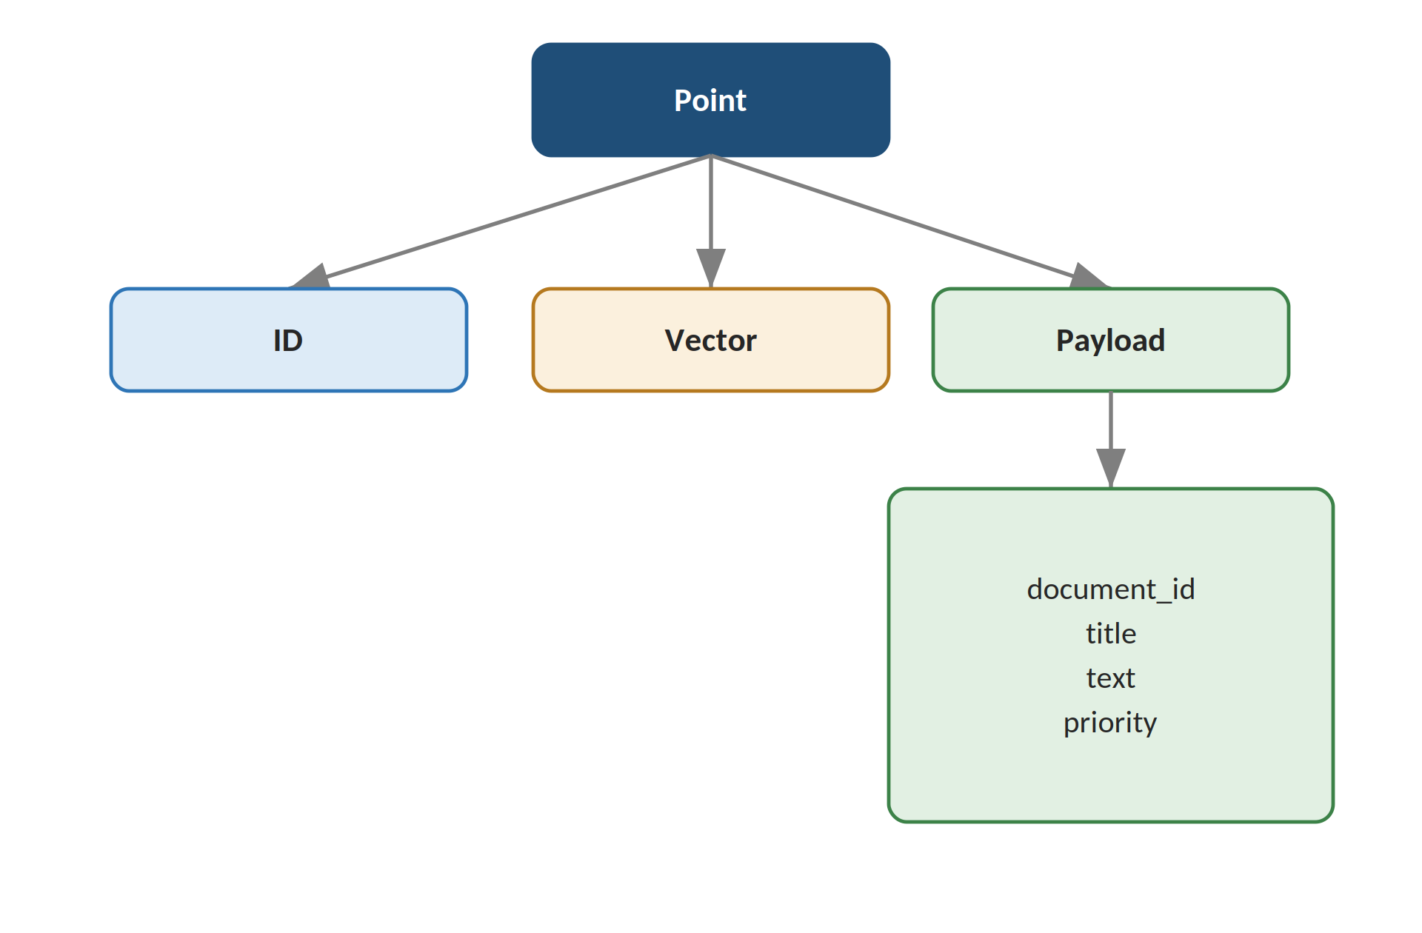
Figure 14.1 - Qdrant point structure
The vector is used purely for similarity search; the payload stores the original metadata needed to interpret and display a match.
Collection: documents

Vector
|
+-- Dimension: based on the embedding model
`-- Distance: similarity metric (e.g. cosine)

Payload
|
+-- document_id
+-- title
+-- text
`-- metadata

The vector dimension configured for the collection must match the output dimension of the selected embedding model; changing the embedding model requires migrating or recreating the collection.

15. Qdrant Upsert Design
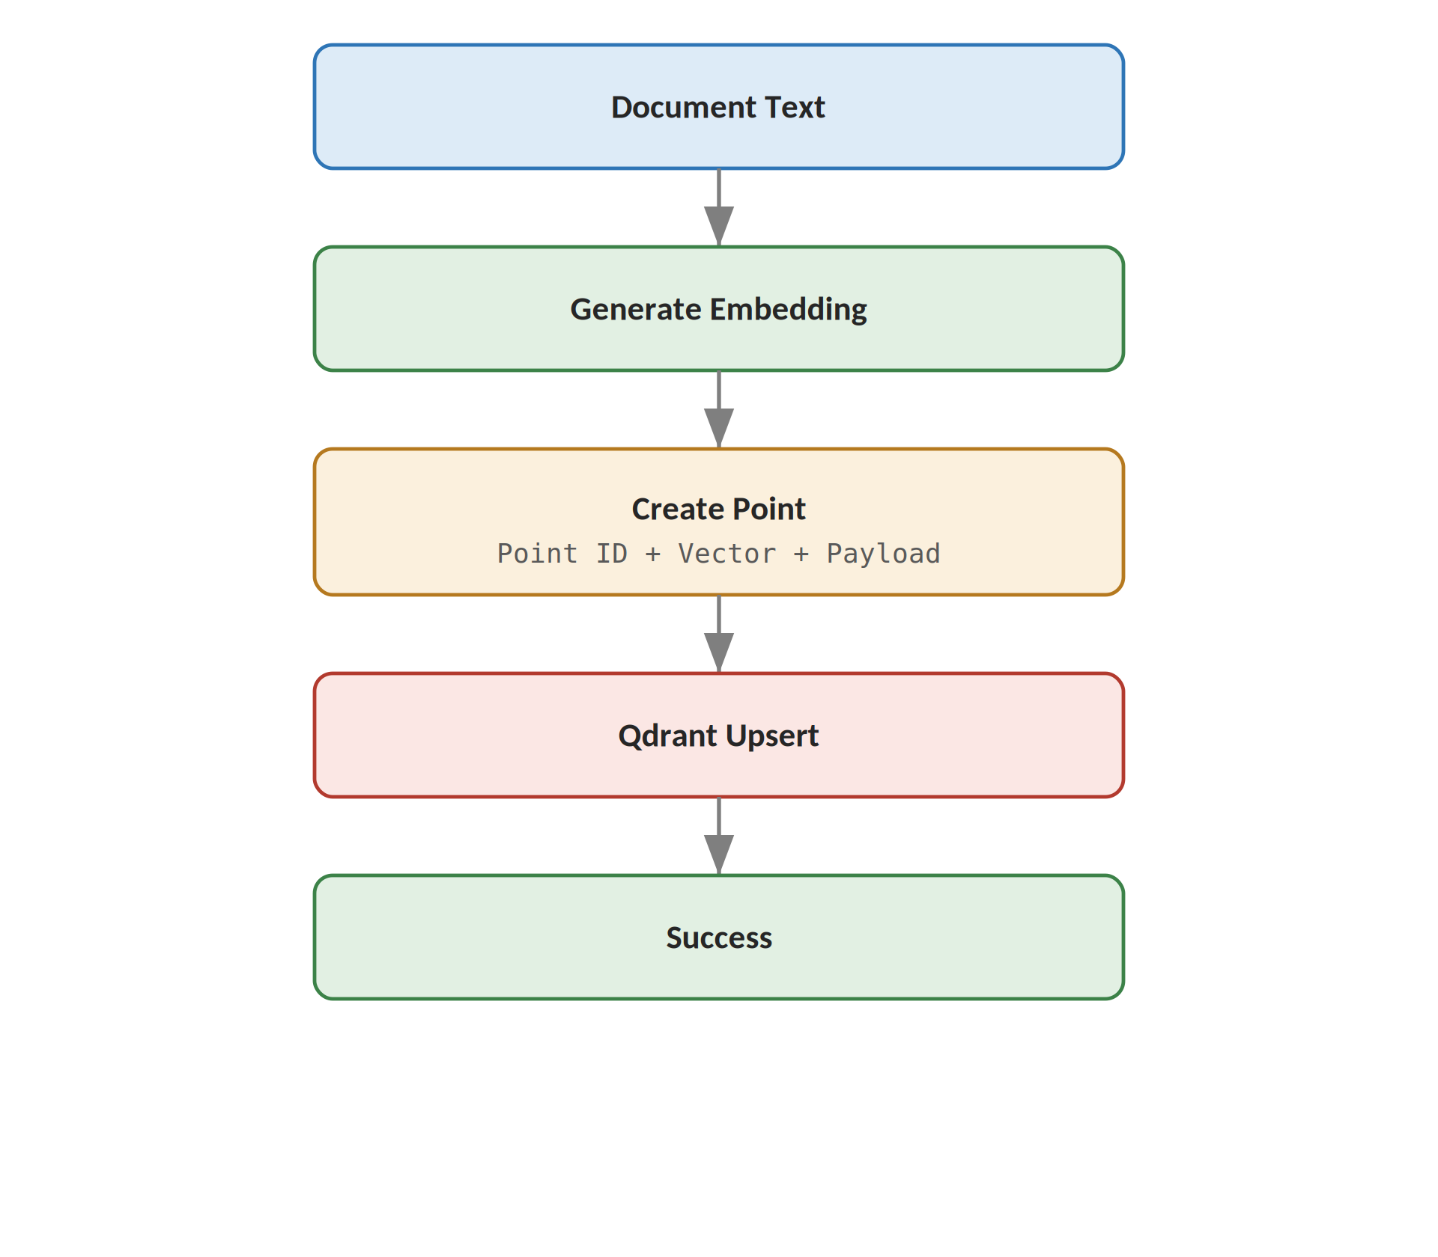
Figure 15.1 - Upsert flow from text to stored point
Point IDs are generated deterministically from the source record's identifier (for example, derived from document_id) rather than randomly. This makes the upsert operation idempotent: reprocessing the same document — whether due to a retry, a redelivered message, or a manual reprocessing step — overwrites the existing point instead of creating a duplicate vector record.

16. Search Architecture
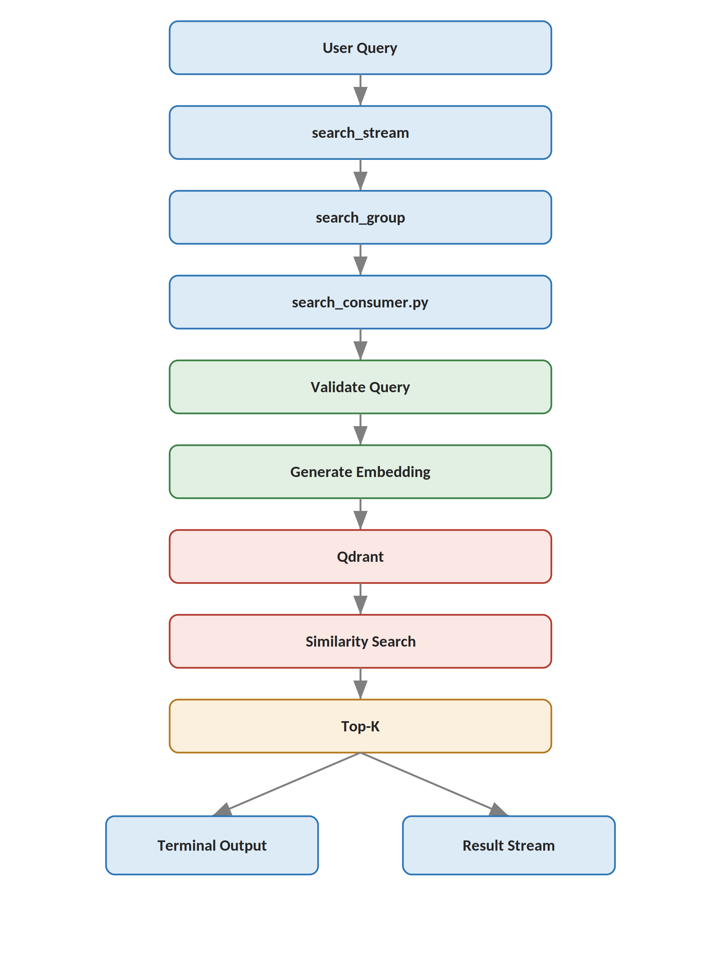
Figure 16.1 - Semantic search pipeline
Example search command:
command = search
query = "What are Redis Streams?"
top_k = 5

Processing stages:
- Query validation — confirms the command, query text, and top_k are well-formed
- Query embedding — converts the query text into the same vector space as stored documents
- Vector search — Qdrant compares the query vector against stored vectors
- Similarity score — each candidate result carries a numeric similarity score
- Top-K selection — only the K most similar results are returned
- Result formatting — results are shaped into the standard result structure before being returned

17. Search Result Design
The result structure is intentionally minimal:
query
result_count
results

Example:
{
"query": "What are Redis Streams?",
"result_count": "2",
"results": [...]
}

Qdrant Results
|
v
Format Results
|
v
Publish to Result Stream
|
v
Display Results

18. Retry and Failure Design
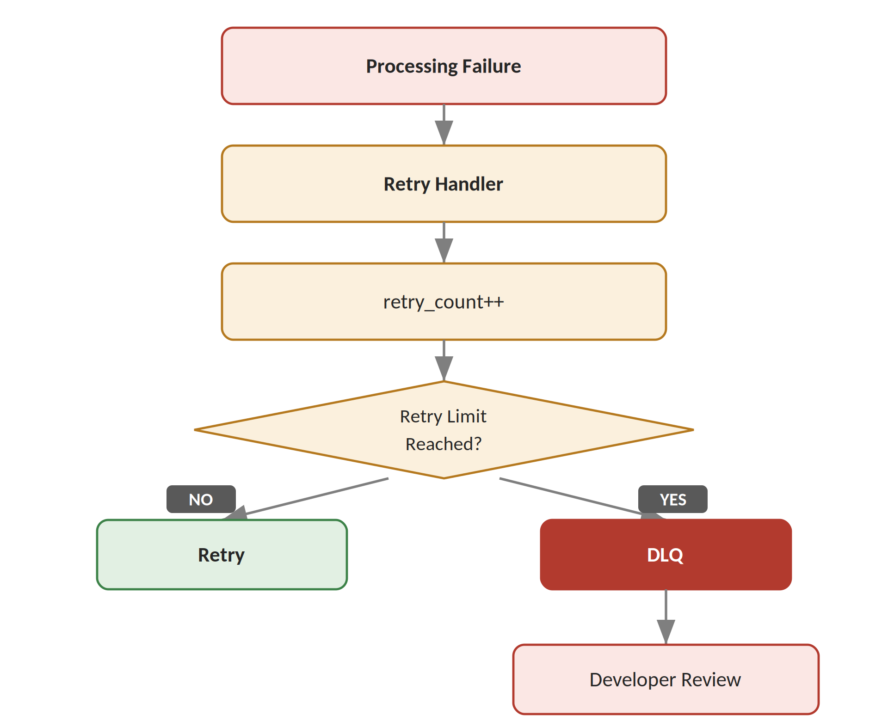
Figure 18.1 - Retry and failure decision flow
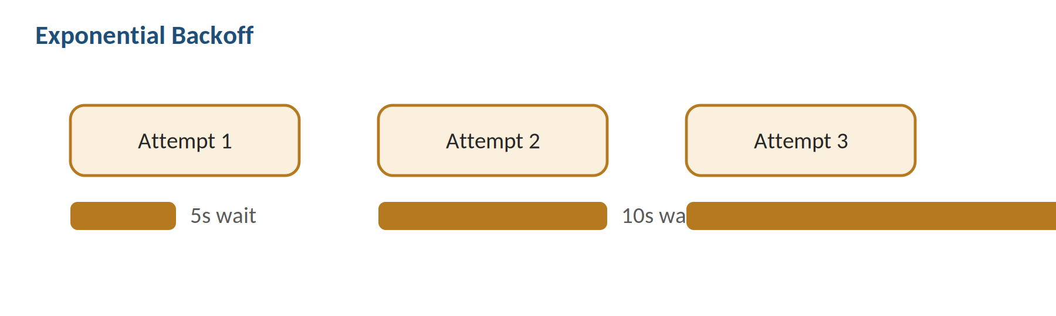
Figure 18.2 - Exponential backoff between retry attempts
The system does not retry continuously, because a tight retry loop against a struggling dependency (Redis, Qdrant, or the embedding model) can worsen an outage rather than help it recover. Exponential backoff spaces each retry further apart, giving the dependency time to recover before the next attempt.

19. Dead Letter Queue Design
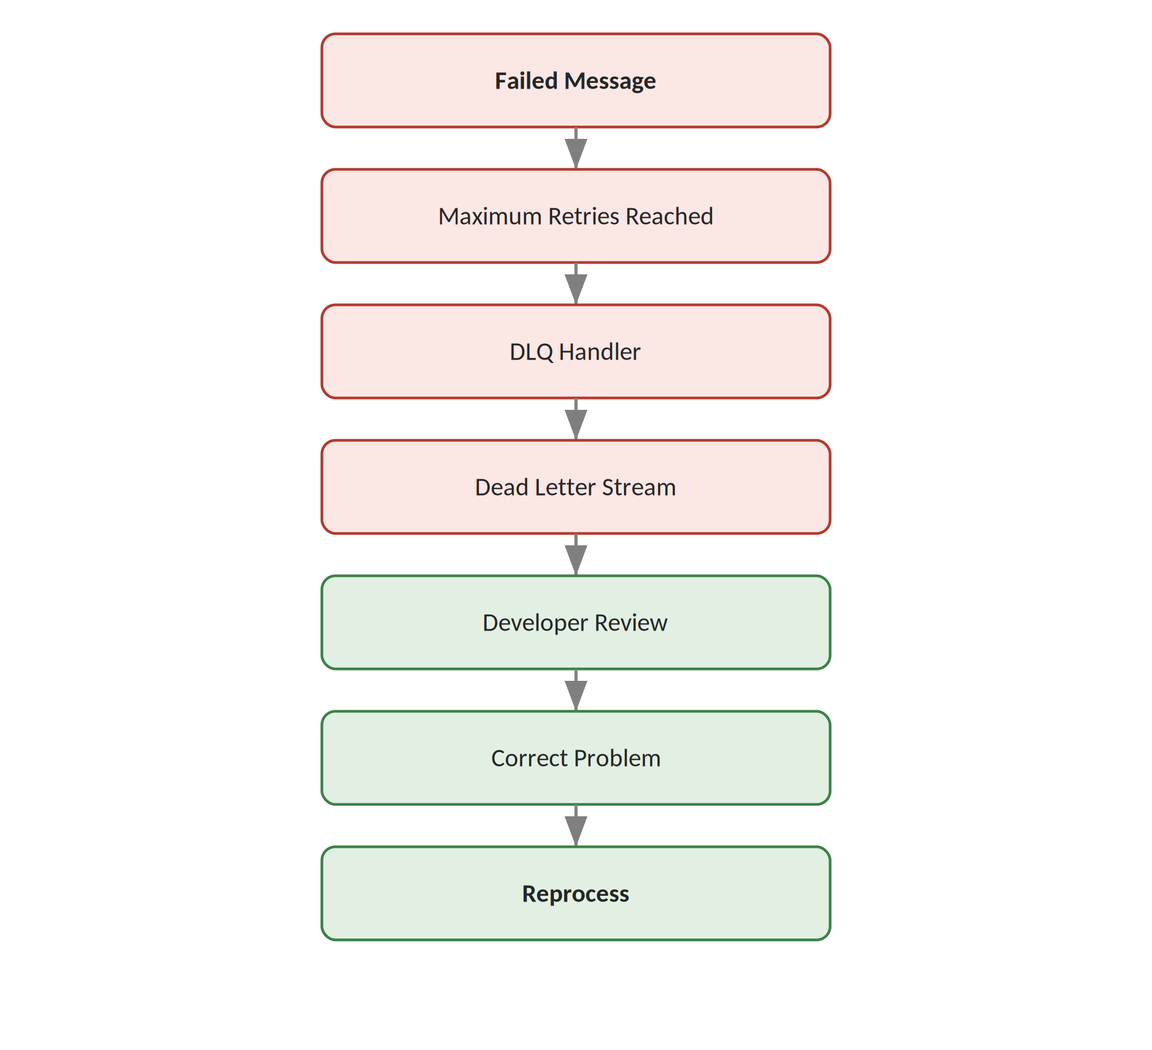
Figure 19.1 - Dead Letter Queue lifecycle
The following information is preserved for every DLQ entry so that a developer can diagnose the failure without reproducing it from scratch:
- Original message
- Original message ID
- Error reason
- Retry count
- Timestamp
- Failure details

20. Email Notification Design
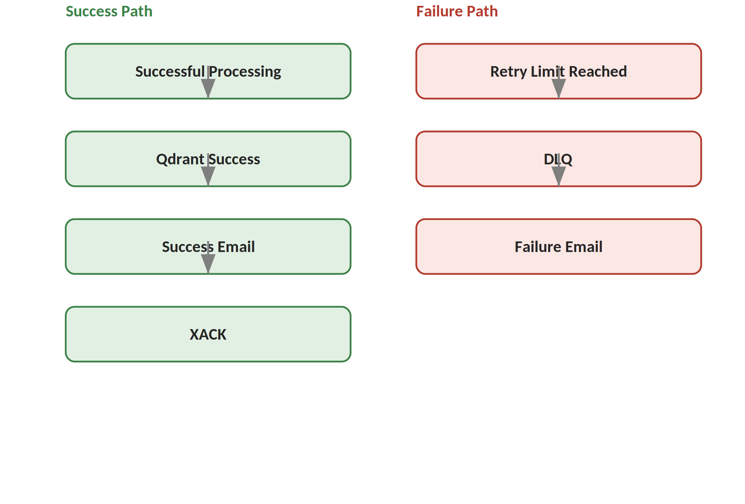
Figure 20.1 - Success and failure notification paths
Notification logic is implemented as a separate service rather than being embedded directly inside the validation, retry, or Qdrant modules. This separation means the core processing logic does not need to know how notifications are delivered, and the notification channel (email today) can be replaced or extended (for example, with Slack or webhook notifications) without touching the processing pipeline.

21. End-to-End Sequence Diagrams

Ingestion Sequence
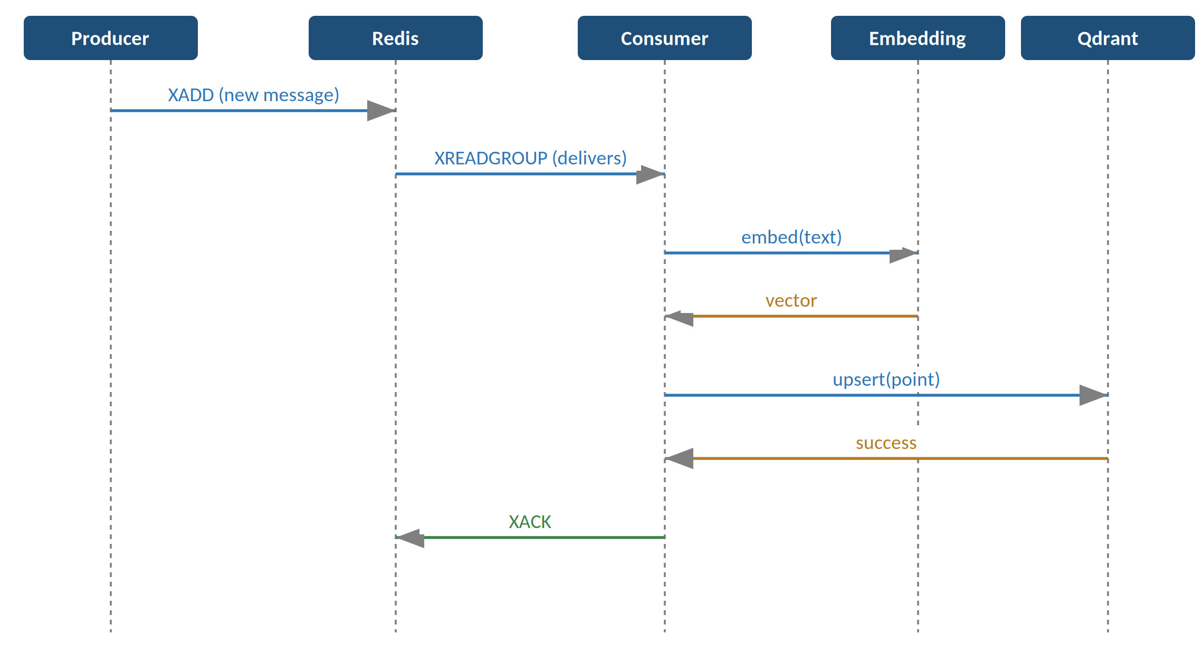
Figure 21.1 - Ingestion sequence: Producer, Redis, Consumer, Embedding, Qdrant

Search Sequence
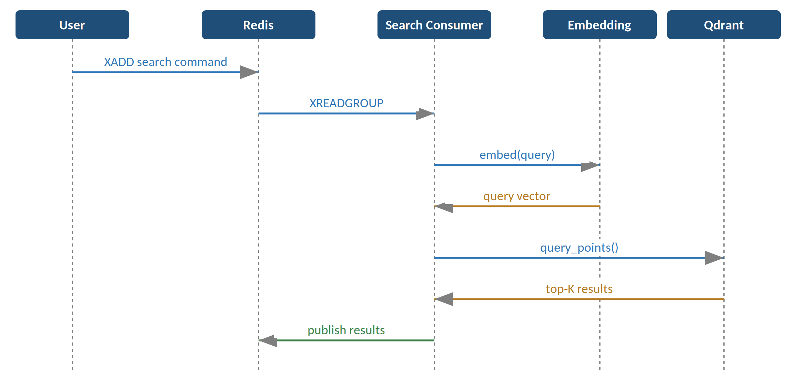
Figure 21.2 - Search sequence: User, Redis, Search Consumer, Embedding, Qdrant

22. Data Flow Design
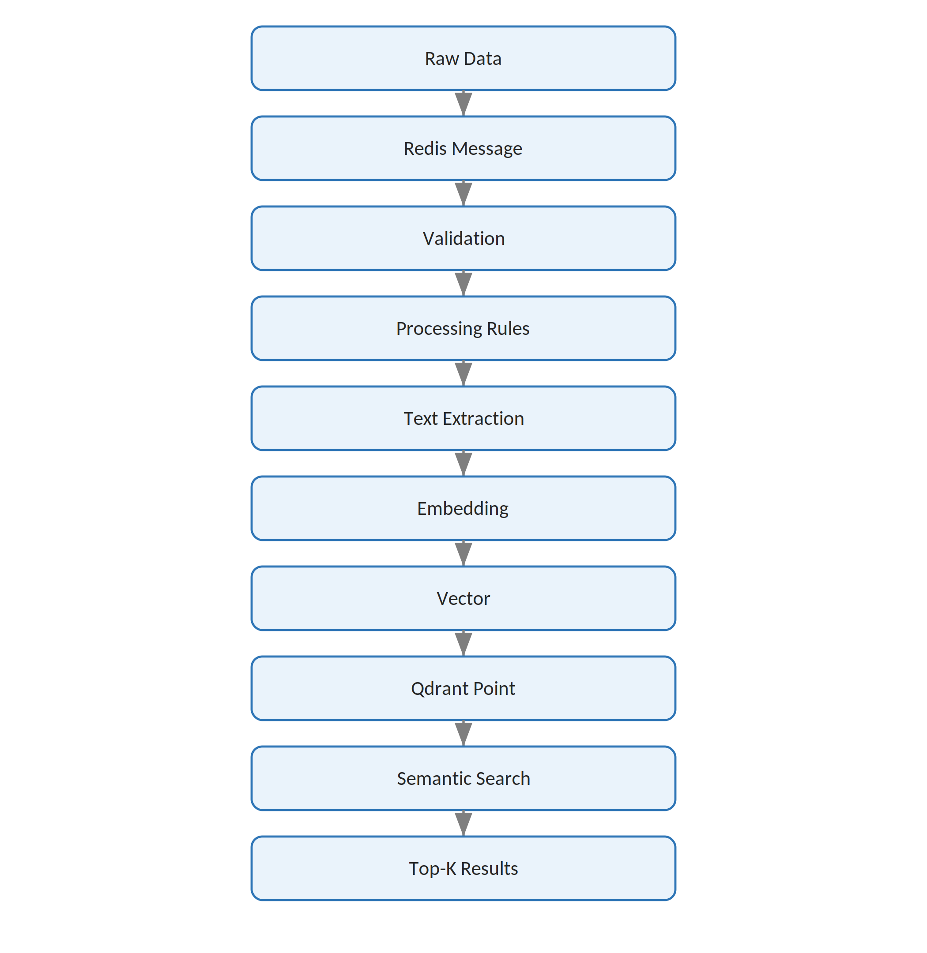
Figure 22.1 - End-to-end data flow from raw input to search results

23. Deployment Architecture
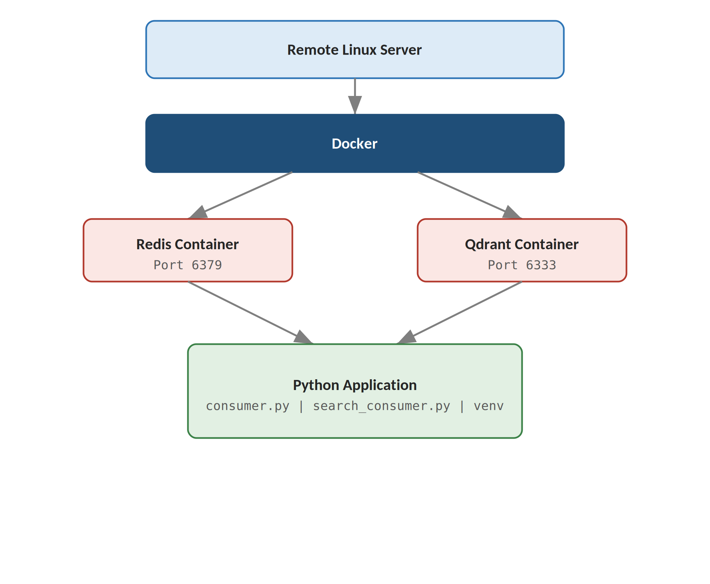
Figure 23.1 - Deployment topology on the remote server
- Redis runs as a Docker container and owns all stream state.
- Qdrant runs as a separate Docker container and owns all vector storage.
- Python consumers run in the application environment (a virtual environment) directly on the host, outside of Docker.
- SSH is used for remote access to the server for deployment and operational tasks.
- Port forwarding (SSH tunneling) can expose the Qdrant dashboard and RedisInsight locally without opening those ports publicly.

24. Docker Design
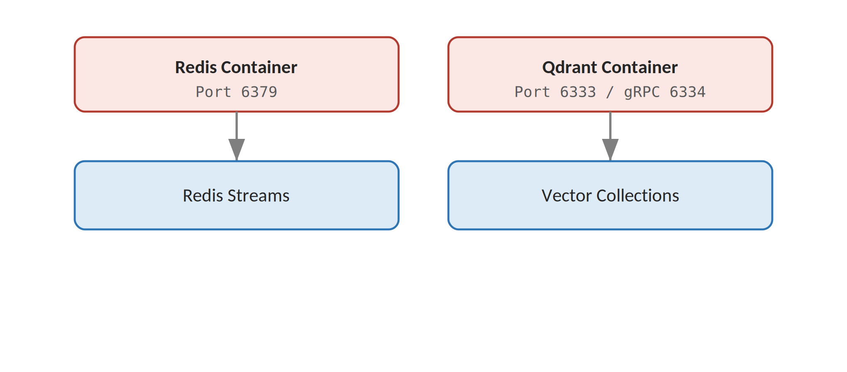
Figure 24.1 - Container responsibilities and ports
Redis -> Port 6379
Qdrant -> Port 6333 (HTTP)
Qdrant gRPC -> Port 6334

Each container owns a single responsibility — Redis owns stream and queue state, Qdrant owns vector collections — and the two never communicate directly with one another; all coordination happens through the Python consumer layer.

25. Reliability Design
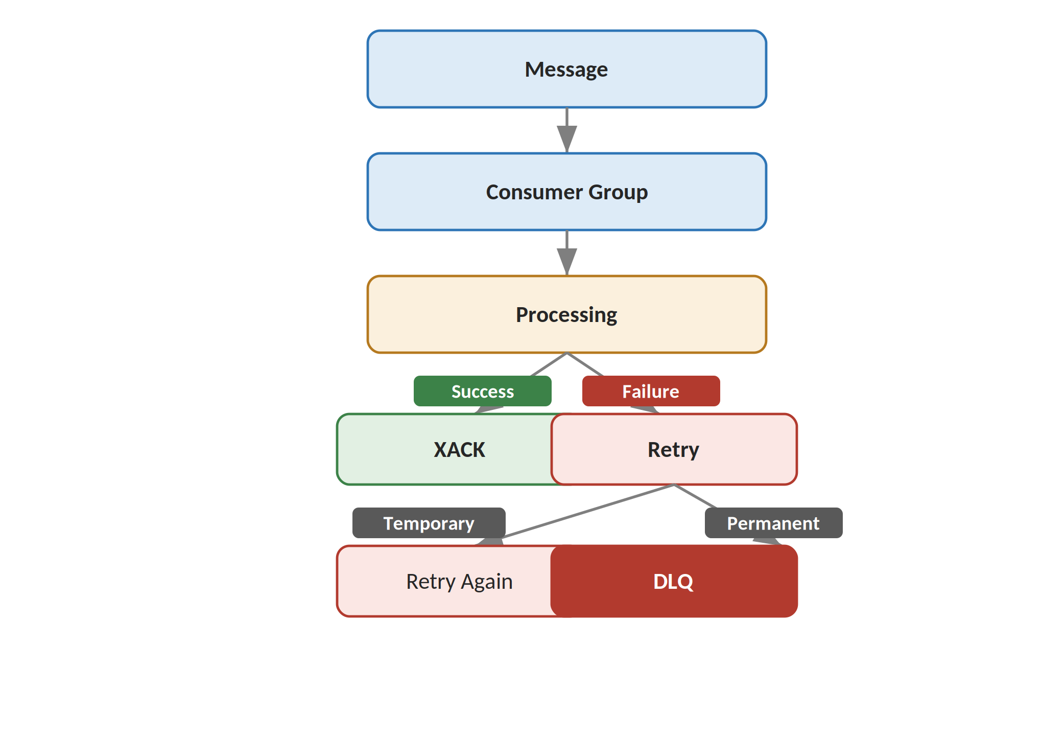
Figure 25.1 - Reliability path from delivery to acknowledgement or DLQ
Reliability is built from a small number of composable mechanisms rather than a single feature:
- Consumer groups guarantee at-least-once delivery of every stream entry.
- Pending message tracking makes it possible to detect and recover work left behind by a crashed consumer.
- Acknowledgement (XACK) is the single source of truth for whether a message is fully processed.
- Retry with backoff absorbs transient failures without operator intervention.
- The DLQ guarantees that a permanently failing message is preserved and surfaced rather than silently dropped or retried forever.

26. Scalability Design
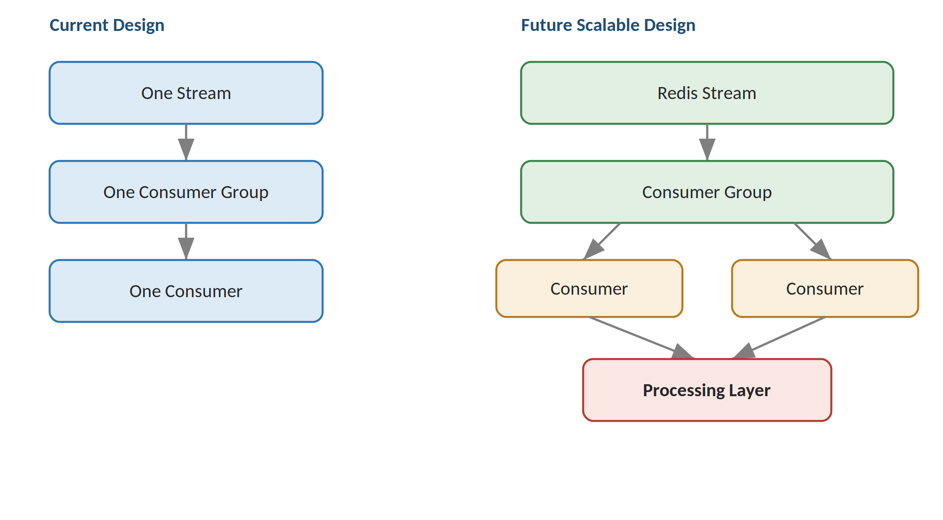
Figure 26.1 - Current single-consumer design versus a future multi-consumer design
In the current design, each stream is served by a single consumer within its consumer group. Because Redis Consumer Groups already support multiple named consumers per group, the system can scale horizontally by starting additional consumer processes against the same group — Redis will automatically distribute new stream entries across all active consumers. Different streams can also be scaled independently of one another, since each has its own group and consumer population.

27. Security Design
- Redis authentication (requirepass or ACLs) to prevent unauthenticated access to stream data
- Qdrant access control (API keys) for its HTTP and gRPC interfaces
- SSH key-based authentication for all remote server access, with password authentication disabled
- Secure environment variables for connection strings, API keys, and email credentials
- No hardcoded passwords or secrets anywhere in source code
- Protected email credentials, loaded from environment variables or a secrets manager
- Firewall configuration restricting inbound access to only required ports
- Restricted ports — Redis and Qdrant ports are not exposed publicly, only reachable via SSH tunnel or internal network
- TLS for production deployments, particularly for any externally reachable endpoint
Secrets are always stored outside source code, using environment variables or a dedicated secrets manager, and are never committed to version control.

28. Observability Design
Logging is structured around three severity levels:
INFO
WARNING
ERROR

Key events emitted at these levels include:
Message Received
Validation Failed
Retry Started
Retry Completed
Embedding Generated
Qdrant Upsert Successful
Search Started
Search Completed
DLQ Published
Email Sent
Message Acknowledged

These logs support four operational needs:
- Debugging individual message failures
- Monitoring overall system health
- Investigating incidents after the fact
- Analyzing throughput and latency over time

29. Design Decisions
Decision | Reason
Redis Streams | Asynchronous message processing
Consumer Groups | Reliable distributed consumption
Python | Flexible processing and ML integration
Embeddings | Semantic representation of text
Qdrant | Vector similarity search
Docker | Consistent infrastructure deployment
Retry | Temporary failure recovery
DLQ | Permanent failure isolation
Separate Streams | Independent processing domains
Search Stream | Asynchronous search request processing

30. Future Improvements
- Multiple consumers per group for higher throughput
- Priority queues instead of a single priority field
- Redis Sentinel or Redis Cluster for high availability
- Qdrant clustering for larger collections
- A REST API for producers instead of direct stream access
- A web UI for search
- Authentication and authorization for administrative operations
- HTTPS for all externally reachable endpoints
- Metrics using Prometheus
- Dashboards using Grafana
- Automatic DLQ reprocessing
- A dedicated scheduler for execute_at handling at scale
- Horizontal scaling across multiple hosts
- Kubernetes-based deployment
- Centralized logging
- Advanced ranking and filtering in search

31. Final Architecture Summary
Data ingestion:
Producer
|
v
Redis Stream
|
v
Consumer Group
|
v
Python Consumer
|
v
Validation
|
v
Priority + Scheduling
|
v
Retry / DLQ
|
v
Embedding Model
|
v
Qdrant
|
v
Email
|
v
XACK

Semantic search:
Search Query
|
v
search_stream
|
v
Search Consumer
|
v
Query Embedding
|
v
Qdrant Similarity Search
|
v
Top-K Results
|
v
Result Stream / Terminal

The architecture cleanly separates six concerns, each owned by a distinct layer:
Message Transport
|
v
Business Processing
|
v
Embedding Generation
|
v
Vector Storage
|
v
Semantic Search
|
v
Failure Recovery

This document is the architectural counterpart to the Operational Document: where the Operational Document explains how to run, monitor, and troubleshoot the system, this document explains how the system is designed and why each component exists, how it interacts with the rest of the system, what data it consumes and produces, and how it behaves under failure.

